31.53: a) 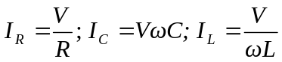.
b)

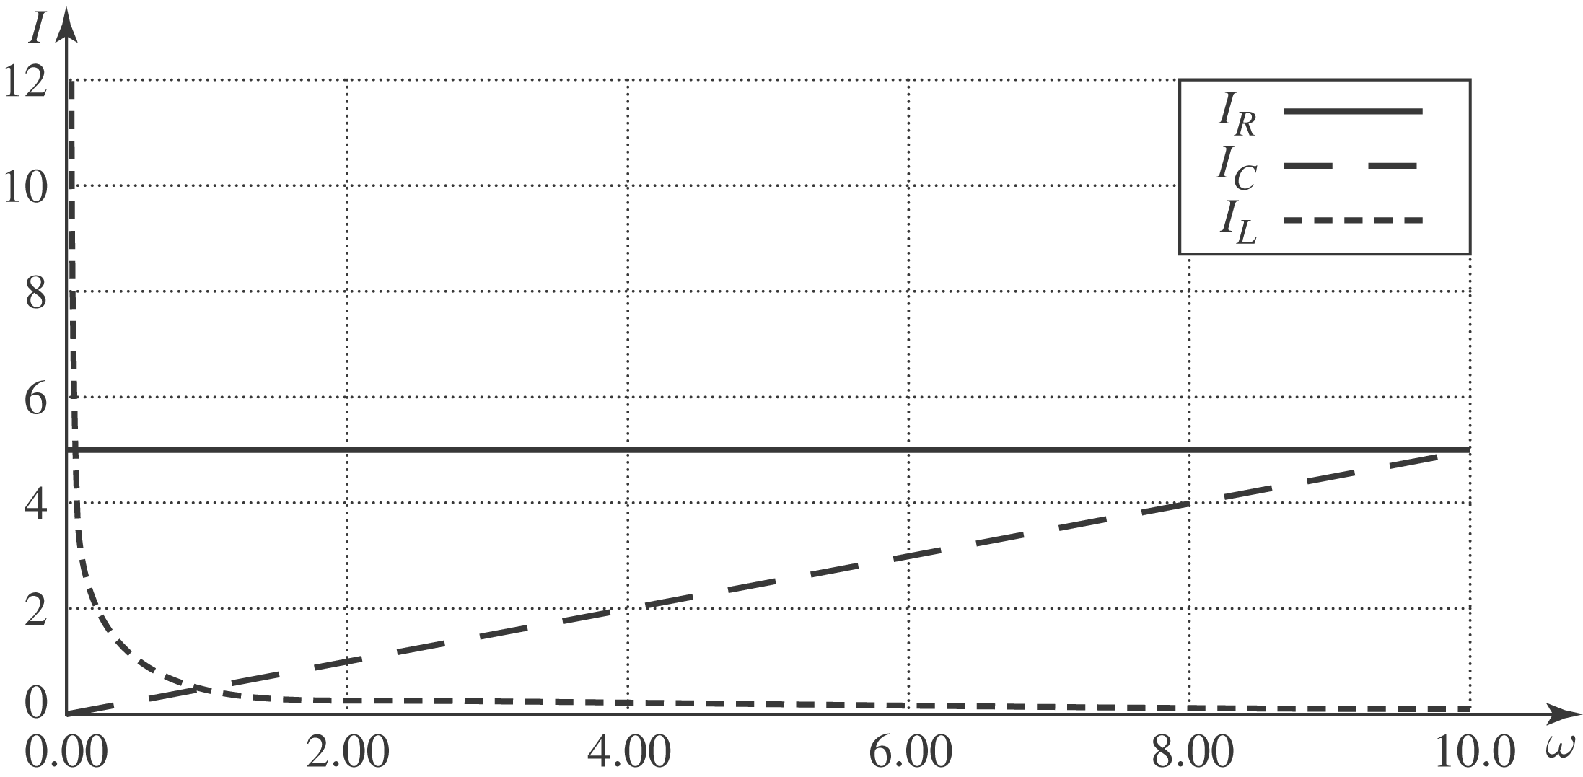

c) .
At low frequencies, the current is not changing much so the inductor’s back-emf doesn’t “resist.” This allows the current to pass fairly freely. However, the current in the capacitor goes to zero because it tends to “fill up” over the slow period, making it less effective at passing charge.
At high frequency, the induced emf in the inductor resists the violent changes and passes little current. The capacitor never gets a chance to fill up so passes charge freely.
d) 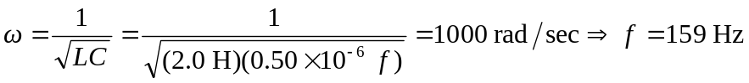

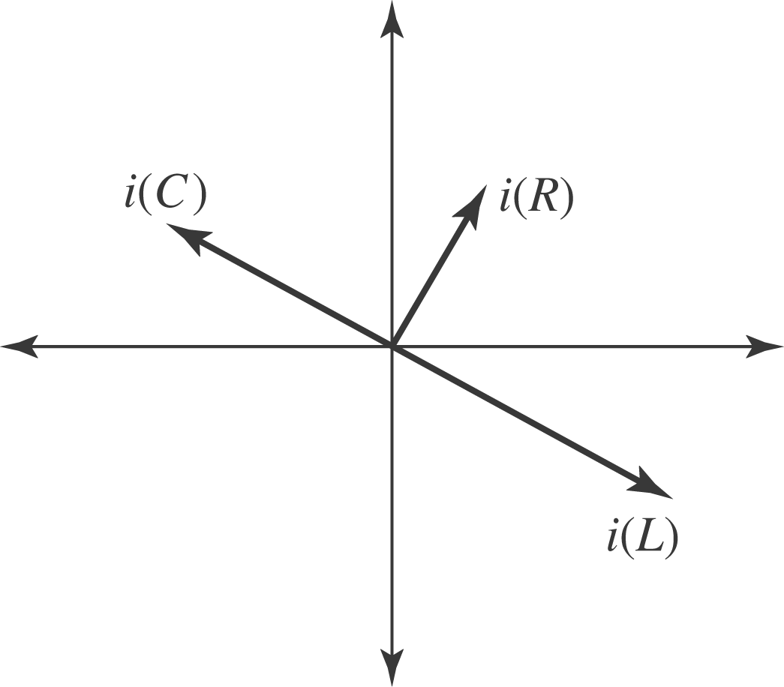

e) 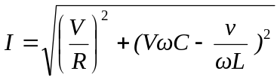
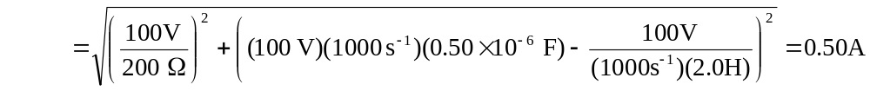
f) At resonance
